Expt 7 Date: /09/2026
Implement Dijkstra’s Single Source Shortest Path algorithm.

Aim: To implement Dijkstra’s Single Source Shortest Path algorithm.
Theory:Dijkstra’s algorithm is a greedy algorithm used to find the shortest path from a single source vertex to all other vertices in a weighted graph.
It maintains the shortest known distance from the source vertex to every vertex. At each step, the algorithm selects the unvisited vertex having the minimum distance and makes it permanent. The distances of its adjacent vertices are then updated if a shorter path is found.

Important points
- Dijkstra’s algorithm works on weighted graphs.
- All edge weights must be non-negative.
- It calculates the shortest distance from one source vertex to all other vertices.
- It uses the greedy approach.
- Once the vertex with the minimum tentative distance is selected, its shortest distance is finalized.
- The process continues until all vertices are visited.
Relaxation:
If d[u] + w(u,v) < d[v], then d[v] = d[u] + w(u,v)
Here, d[u] is the shortest known distance to vertex u, w(u,v) is the weight of the edge from u to v, and d[v] is the current distance to vertex v.
Limitation
Dijkstra’s algorithm should not be used when the graph contains negative edge weights. For graphs with negative edge weights, algorithms such as Bellman-Ford are more appropriate.

Algorithm:
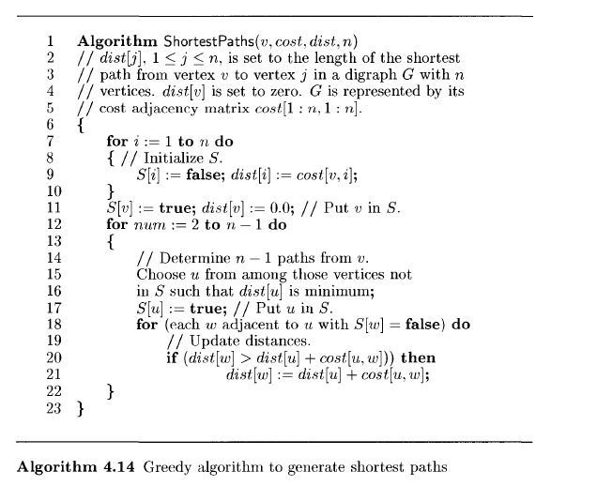
Pseudocode
DIJKSTRA(Graph, source)
1. For each vertex v:
d[v] = ∞
visited[v] = false
2. d[source] = 0
3. Repeat:
Select unvisited vertex u having minimum d[u]
Mark u as visited
For every adjacent vertex v of u:
If d[u] + w(u,v) < d[v]:
d[v] = d[u] + w(u,v)
4. Display d[]

Task : Write a C/C++ program to implement Dijkstra’s Single Source Shortest Path algorithm to find the shortest distance from a given source vertex to all other vertices in a weighted graph having non-negative edge weights.
Note: The program should be fully user-input based, can enter:
- Number of vertices
- Adjacency matrix
- Source vertex

Code:

Output:

Conclusion:

